We have created three homework tasks to enrich our topic, House point tokens will be awarded for work completed. Each task shows when it can be handed in – please don’t hand it in before the date shown.
Please support your child with each task but don’t complete it for them!

Have a go at learning a magic trick or maybe a circus skill! There are plenty of different tricks on this website: https://www.care.com/c/stories/4051/easy-magic-tricks-for-kids/
You will then be able to perform your trick or skill at our ‘Grand Magical Bazaar!’
Due on Tuesday 22nd October
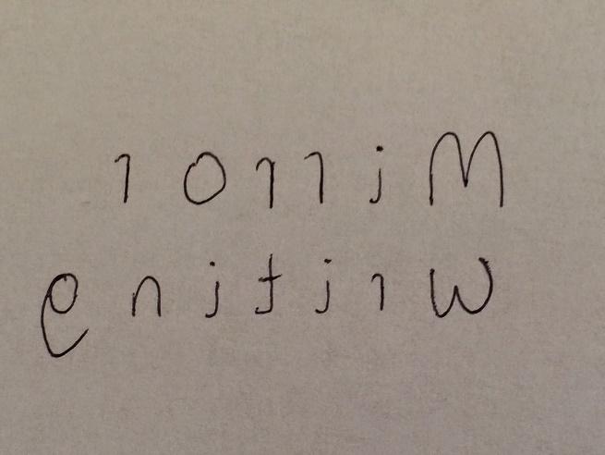
Using a mirror have a go at writing a secret mirror writing message. Will anyone be able to crack your secret message?

You will have a chance to share your secret message in a code-cracking session.
Due on Tuesday 12th November
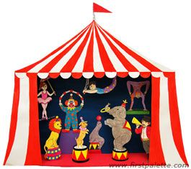
Have a go at creating your own mini circus Big Top. Use whatever you like to create it. Maybe you might even decide to design some characters who perform at your circus. This website might be useful: https://www.firstpalette.com/craft-theme/circus.html

Due on Tuesday 3rd December
Each piece of homework does not need to be completed in one go but it should be completed with care. Thank you!

