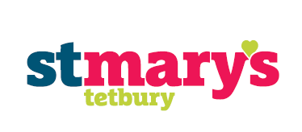

11th January 2019

Year 3 visit to ‘Clearwell Caves’

Dear Parents and Carers,

As part of our learning this term we would like to take the children to Clearwell Caves on Tuesday 12th March. The day will enrich the children’s learning in a hands-on and exciting way. We believe this will be an incredible opportunity that the children will remember for the rest of their lives. They will have the chance to gear up in helmets, crawling and clambering into areas visitors wouldn’t normally venture. If you would like to find out more information about the caves, please visit: https://clearwellcaves.com/ . This will be our only trip this year as we have decided to go for one larger, extremely enjoyable trip as opposed to having multiple, smaller trips and activities throughout.

Whilst this is a valuable activity for the children it cannot be considered essential, therefore we are asking for a voluntary contribution of up to £16.63. This includes the coach, entry ticket and guided tour by an experienced cave guide. This contribution can be paid online via ParentPay or through cash/cheque (payable to St Mary’s School Fund) to the office. We appreciate your contributions and hope to receive sufficient funds to enable this trip to go ahead.

Please send your child in with a packed lunch, in a paper/disposable bag, unless your child is eligible for Free School Meals (FSM). This saves the children having to carry lunchboxes around with them afterwards. If your child is eligible for FSM and you wish for them to have a packed lunch, please let us know. We will travel by coach leaving school after registration and will arrive back for the end of the school day and expect the children to be dressed in warm, outdoor clothing that can get muddy (think Forest School). More information will follow closer to the time regarding the logistics of the trip.

Thank you for your continued support.
Mrs Wilson, Mr Walters and Mr Hainsworth
Class Teachers
......................................................................................................................................................................
Clearwell Caves Trip Y3

I give permission for my child (name) ........................................................................... in ......................... class to visit Clearwell Caves on Tuesday 12th March.

I have made a voluntary donation of £16.63 via Parent Pay/cash/cheque. (Please delete as appropriate)

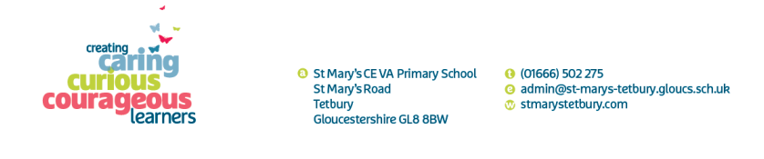
Signed ..................................................................... Parent/Carer

